Kol Simcha Torah Gazette
For parshas chaya sara 5786
Vol 10 Issue 7 (Whole #472) 24 Cheshvan 5786/ November 15, 2025
Printed L’illuy nishmas Nechama bas R’ Noach, a”h
For a free subscription, please forward your request to keren18@juno.com
Past emails can be found on the website ShabbosStories.com under Brooklyn Torah Gazette
Kosher to Leave Negative Reviews Online?
By Yehuda Shurpin


Art by Sefira Lightstone

We’re used to the concept of “freedom of speech” and the notion that we’re all allowed to say whatever we want.
However, from a Torah perspective, we’re responsible for what we say, and the laws of lashon harah, the prohibition against disparaging or gossiping, applies to leaving a review as well.
Generally, even if what you’re saying is true, if it may damage someone’s reputation or cause financial harm, it can potentially be problematic even if you don’t have any negative intentions.¹
However, there are times when not only are you allowed to leave a negative review, but it would be your obligation to do so.

The following guidelines are enumerated in the book Chafetz Chaim, by Rabbi Yisrael Meir Kagan (commonly known as the Chafetz Chaim):²
- It must be for a benefit: The objective of publicizing the wrongdoing must be a legitimate benefit, such as warning others so that they’ll be protected from harm.
- It must be true: You must be certain that the information you have is factually correct. Additionally, this cannot be second-hand information.
- It must be relevant and objective: You may only write the relevant facts objectively; any exaggeration violates the prohibition of speaking falsehood. So, for example, saying an establishment is expensive (even if it is more expensive than other stores in the area³ ) or that the food is not tasty are subjective judgments and are prohibited.
- Confront the vendor first: If there is a possibility that the vendor will rectify the situation without you having to publicize the negative information, you are obligated to try that route first. For example, many online retailers, when warned about a possible negative review, are more than willing to rectify the problem.
- The benefit outweighs the loss: The potential damages you are averting by your review are greater than the potential damage to the offender. For example, leaving a single star review saying a certain establishment regularly forgets to send napkins with your order may lead them to remedy the problem, but it may also scare off many potential customers, who would otherwise be happy, causing greater unwarranted loss to the restaurant.
- No other recourse: There must be no other means by which the desired effect can be achieved. If there is a way to accomplish what you need to without saying negative things (or by keeping it to a minimum and still having the desired result), then you need to do that.
- Check your motivation: Why are you leaving this review? Is it genuinely to help others avoid the same pitfall or to encourage the establishment to improve, or are you feeling spiteful and angry? If the motivation is a long-standing grudge (even if what is being posted is true) or a desire to ridicule the wrongdoer, the review should not be made.
Where to leave the review
As we noted, one of the criteria for leaving a review is that it be beneficial. The laws of negative speech apply both to the one speaking or leaving the review as well as the one who receives the report. In light of this, one should only leave the reviews in a place that would indeed prevent one from being victimized (for example, on the product page). Posting a negative review on social media, for example, where you know it isn’t really relevant to most of those reading it, can be problematic.
Our sages tell us that many of the exiles, including our present exile following the destruction of the Second Temple, were brought about through negative speech. Through being extra careful with our speech (and writing) about others, we have the ability to rectify this and bring about the ultimate Redemption. May it be speedily in our days!

Reprinted from the current Chabad.Org website.
Rav Avigdor Miller on How
Do We Account for the Variety
of Jewish Religious Groups

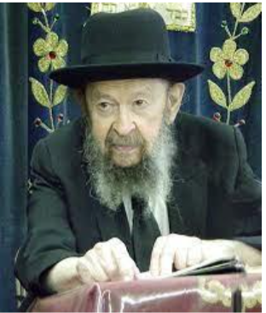

And the answer is; in a garden, how do we account for the variety? There are red flowers and there are blue flowers and pink and white. And baruch Hashem the variety causes it to be more interesting and beautiful. We have to know that each group contributes its specific contributions to our people. Not everybody has all the maalos. And each one is essential to the wellbeing, and the happiness, and the beauty of our nation.
And therefore, when Beis Hillel and Beis Shammai had a machlokes, it wasn’t a reason for weeping and moaning about variety. We have to know that Beis Hillel and Beis Shammai together upheld the Torah; each one served Hakadosh Baruch Hu in his way, and each one sharpened the other by their conflict. – One piece of iron causes the other iron to sharpen (Mishlei 27:17).
And even the conflict between chassidim and misnagdim, for instance, had a very good effect. There was an old writer, the Zichron Yakov, and he said because the misnagdim so frequently and so much accused the chassidim of not learning, the chassidim began learning as much as the misnagdim did. And the misnagdim started learning other things, mussar and yiras Shamayim, in order to show that they had the same avodas Hashem like the chassidim.
And so, after a while the besamim of one rubbed off on the other and the good qualities began to diffuse. And that’s Hakadosh Baruch Hu’s system when He made the twelve shevatim; each shevet had its own qualities, very different from the other shevatim. But all together they contributed and they made it a perfect whole. February 1982

Reprinted from a recent email of Torah Avigdor based on a lecture delivered sometime in 1970).

ּThe Virtues of Sarah Imanu

And the life of Sarah was 100 years and 20 years and seven years... (23:1)

She Always Felt Good:
Rashi states that the reason the word “years” was written after every digit is to tell us that every digit is to be expounded upon individually. When she was one 100 years old, she was like a 20-year-old regarding sin. Just as a 20-year-old has not sinned, because she is not liable to punishment, so too when she was 100 years old, she was without sin. And when she was 20, she was like a seven-year--old in regards to beauty. Rashi then says: “The years of the life of Sarah: All of them were equally good.”
The Yesod Ha’avodah of Slonim zy”a (quoted in Sefer Kisvei Ramam) explains Rashi’s words by saying: “It was always good for her.” Since she completely believed and trusted that everything Hashem does is for her benefit, she always felt good with whatever He caused to happen to her.
Reprinted from the Pashas Chaya Sara email of The Way of Emunah.
The Connection Between Isaac and the House of David
From the Teachings of the Lubavitcher Rebbe
Rabbi Menachem Mendel Schneerson, Zt”l


The end of this week's Torah portion, Chayei Sara, tells of the passing of Abraham and the order of succession of his descendants: "And Abraham gave all that he had to Isaac." Isaac, Abraham's only son from his beloved wife Sara, was chosen to continue the new path he had forged in the service of G-d. The children of Abraham's concubines, however, received only a token of their father's wealth: "But to the sons of the concubines...Abraham gave gifts, and sent them away from Isaac his son." Isaac was designated his father's heir, despite being younger than Ishmael and the others.
This week's Haftara contains a similar incident that occurred toward the end of King David's life. When Adoniyahu, David's eldest son, sought to usurp his father's throne, Batsheva reminded David of the oath he had made that Solomon, the younger son, would reign. King David agreed to honor the oath and Batsheva declared, "May my lord, the King David, live forever!"
What is the significance of both these choices? When Abraham designated Isaac his heir, he thereby bestowed upon him the special relationship he enjoyed with G-d, the essential "chosenness" he would pass on to his children after him. Abraham's choice of Isaac allowed every Jew to acquire that same eternal bond with G-d as his birthright, an immutable bond that can never be severed.
Similarly, Batsheva's declaration, "May my lord, the King David, live forever!" is an expression of G-d's promise that "the kingship will never be cut off from the progeny of David." Dominion over the Jewish people belongs solely to the descendents of King David through his son Solomon, ultimately one of whom is King Moshiach.
The common thread between these two incidents is the underlying principle that the actions of an immutable G-d are eternal and unchanging. Just as G-d Himself experiences no change, so too are His choices fixed and immutable. Batsheva's declaration, "May my lord, the King David, live forever!" will find ultimate fulfillment when King Moshiach arises and ushers in the Final Redemption.
Indeed, we find that the wholeness of the Jewish people is connected to the concept of kingship, for it was only after King David's descendants were chosen to rule that the Jewish nation was at peace, the Holy Temple was built in Jerusalem and G-d's Divine Presence dwelt in the Holy Temple. Likewise, the Final Redemption of the Jewish people will only commence when the ultimate King of the House of David arises, to initiate the Ingathering of the Exiles and build the final and indestructible Third Holy Temple, speedily in our day.

Reprinted from the Parashat Chayei Sara 5763/2002 edition of L’Chaim, a publication of the Lubavitch Youth Organization. Adapted from the works of the Lubavitcher.

After Mamdani’s Victory: A Message to New York’s Jews
By Rabbi Chaim Steinmetz

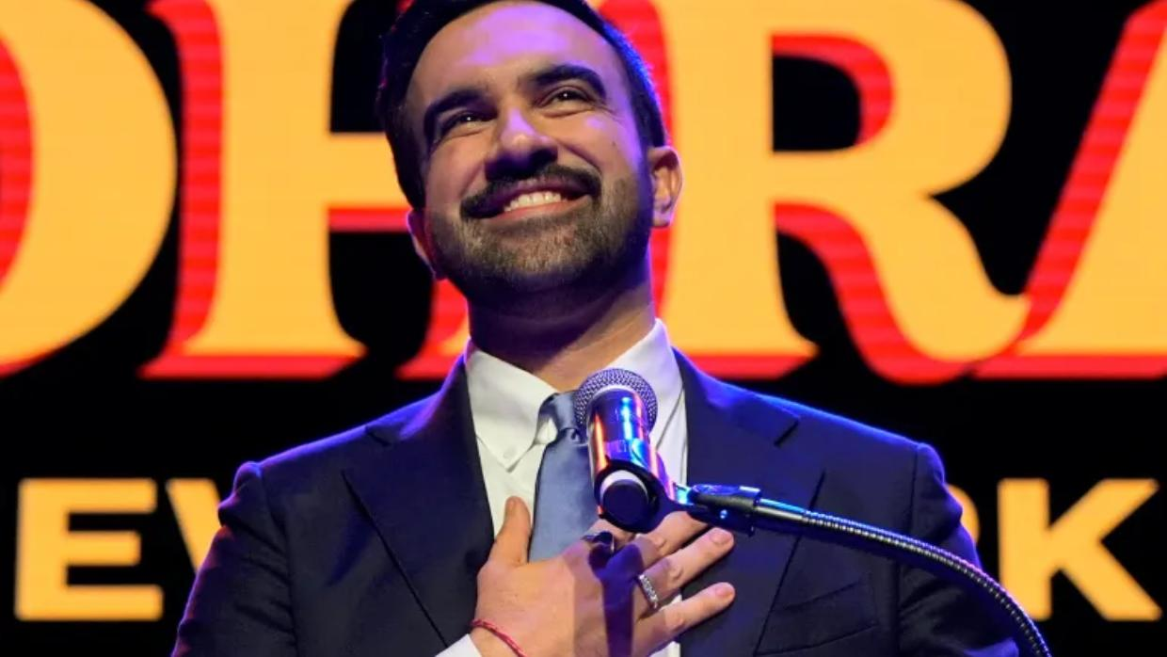
Now is the time for Jewish unity, courage, and renewed leadership — to turn loss into strength and division into resolve.

There is no way to sugarcoat it: Zohran Mamdani’s election was a crushing defeat for the Jewish community of New York. We worked so hard to stop the DSA machine, but came up short. The city with the single largest population of Jews in the world has just elected an anti-Zionist mayor.
Watching the rejoicing Mamdani campaign is painful. So many of his supporters have taken to social media to gloat about defeating the “Zionists.” Their candidate has won, and these snarky anti-Zionists will set the agenda in the years to come.
It is humiliating for a community that has long had a place around the municipal table to be reduced to beggars, hoping for some crumbs of attention from the new mayor.
Unquestionably, there will be postmortems about our community's failure. Yes, we faced a nearly impossible task: electing a deeply unpopular candidate who ran against a slick, smiling, Teflon candidate. Even so, this election exposed our community’s weakness.
We are years behind Mamdani’s backers, the Democratic Socialists of America (DSA), in terms of organization and recruitment. The DSA had an army of canvassers willing to take their cause into the streets, and they have a pipeline developing candidates for every possible elective position.
Even more painful is that this defeat shone a light on internal weaknesses in our community. A significant cohort of young Jews is less attached to Israel, or even anti-Zionist. Many proudly declared they were “Jews for Mamdani.” How many fall in this group is unclear, but it may be as many as 30% of 18- to 29-year-olds.
This probably correlates with assimilation among young Jews. Those who are less attached to Israel are often less attached to Judaism. But that offers no comfort at all. It is still a tragedy that so many are alienated from their Jewish identities.
The election campaign has also exposed ugly rifts within our community. Some passionate opponents of Mamdani lashed out at fellow Jews they felt had failed them.
These attacks allowed people to vent their anger, but they did nothing to stop Mamdani. On the contrary, they threaten to tear apart our community.

Jews must come together as antisemitism rises on both sides
Division is the Achilles’ heel of the Jewish people. We often fight each other, only to have our enemies exploit our divisions. The Talmud condemns what it calls sinat chinam (pointless hatred), which it blames for the destruction of the Second Temple. Multiple Jewish factions focused first on fighting each other, paving the way for the Romans to conquer the country.
This is not just a history lesson. If our community cannot unify, we will certainly fail.

Zohran Mamdani and Tucker Carlson represent a new era in American politics in which populists demonize Israel to advance their own agenda.
To add even more angst, this election comes at a time when both the Left and the Right are turning away from the Jewish community. Zohran Mamdani and Tucker Carlson represent a new era in American politics in which populists demonize Israel to advance their own agenda. Antisemitism is going mainstream, and we are shocked to find former friends peddling bizarre conspiracy theories.
It is a very difficult time for New York Jews. It's beginning to feel like the 1930s.

Our vacation from history is over.
aaaaaaaaaaaaaaThings used to be easier. Although not every politician felt comfortable with Israel or the Jewish community, it was usually a product of ignorance. The old playbook was to create relationships, advocate, and educate these opponents. This was often very effective. Some ended up being passionate supporters of Israel.
That was then. Right now, we need to throw out the old playbook.
Mamdani is a mayor unlike any other. I know some are optimistic that he will turn out to be more moderate than his platform.

Unfortunately, that is wishful thinking.
Mamdani is a talented politician who knows how to project an image of concern and understanding. But you cannot judge a candy by its wrapper. Mamdani has very troubling associations. He campaigned with Imam Wahhaj and palled around with Hasan Piker. Statements he makes in unguarded moments, like “the boot of the NYPD on the necks of Black and brown New Yorkers was laced up by the IDF,” show what Mamdani really believes.
Considering that Mamdani’s parents and wife are far more radical than he is, one has to assume that Mayor Mamdani will not magically moderate.

Reason to be Optimistic
Yes, there's no sugar-coating our current predicament. However, yes, there is a however. There is a very good reason to be optimistic.
We can take a different approach, and we can succeed.
After Jeremy Corbyn won the leadership of the UK’s Labour Party, the Jewish community organized with a passion. For five years, the community took their case to the public, exposed antisemitism in the Labour Party, and worked tirelessly to oppose Corbyn’s initiatives.
And it worked.
We must do the same, and I'm confident that we will.
This election campaign has been a test of our community's character. Nachmanides writes about the biblical concept of a test. He offers the profound insight that a test is not there to discover who you are. A test forces you to become who you can be. A test is a challenge that brings out previously unseen potential.
Every test transforms you.
And this test has transformed our community.
We've seen the best of our community in the last few months. We were determined. We worked hard. Volunteers, young and old, door-knockers, all were available to campaign at a moment's notice.
We fought the good fight.
As Jews, we know our history, which has its triumphs and even more challenges. There is one common lesson in all of this history: we never lost faith in ourselves. We never quit. Nothing stopped us from pursuing our destiny.
Yes, Mamdani’s election is a difficult defeat. However, we have overcome far worse in the past.
And we will overcome again.
Am Yisrael Chai!

Reprinted from the current website of aish.com

Thoughts that Count

Hear us, my lord (Gen. 23:6)
As a token of their respect, the sons of Chet addressed Abraham as "my lord." Abraham, however, refused to reciprocate, even in his business dealings. Abraham, the first Jew, reserved the term solely for G-d, despite social convention. (Rabbi Yosef Horowitz)

And the servant ran to meet her (Gen. 24:17)
According to the commentator Rashi, it was only when Eliezer saw the well water miraculously rising toward Rebecca that he decided she would make the perfect wife for Isaac. Yet only the water Rebecca drew for her own use rose up by itself; the water she drew for Eliezer and his camels had to be brought up by hand. We learn from this that although G-d may perform miracles to assist a righteous person, when it comes to doing mitzvot, it is preferable to perform them oneself in a natural manner and not to rely on miracles. (Rabbi Levi Yitzchak of Berditchev)

And Abraham gave all that he had to Isaac, but to the sons of the concubines...he gave gifts (Gen. 25:5-6)
Isaac is symbolic of holiness and the spiritual realm; the "sons of the concubines" stand for the physical and corporeal world. The Torah teaches that we must give "all" of ourselves - the lion's share of our time, energy and talents - to spiritual matters. Worldly matters, however, can be placated with "gifts." (The Lubavitcher Rebbe)

You shall not take a wife for my son from the daughters of the Canaanites (Gen. 24:3)
Although Abraham's relatives were idol worshippers like the Canaanites, they were not similarly degenerate in the moral sense, a trait passed on from generation to generation. Abraham's family may have held false religious beliefs, but mistaken ideas are not hereditary. (Avnei Ezer)

Then Abraham expired, and died in a good old age (Gen. 25:8)
On the day that Abraham passed away, the greatest of the nations cried, "Woe to the world that has lost its leader; woe to the ship that has lost its captain." (Talmud, Baba Batra)

Among all of his [Ishmael's] brethren he settled (lit. "fell") (Gen. 25:18)
With these words the Torah portion of Chayei Sarah concludes, to be followed immediately by, "And these are the generations of Isaac, the son of Abraham," the beginning of the Torah portion of Toldot. This alludes to the ultimate fall of Ishmael in the End of Days and the subsequent triumph of Moshiach, the son of David, who is descended from Isaac. (Baal HaTurim)

Reprinted from the Chayei Sar 5763/2002 edition of L’Chaim.

Three Inspiring Stories

Arye Leib had a great desire to go and learn in the Yeshiva of Grodno. Although, not the brightest of kids, but Arye Leib had a fire burning in his heart to learn Torah and to be able to study under the world renown Rosh Yeshiva Rabbi Shimon Shkop. Arye Leib traveled over a week until he arrived in Grodno. He was very nervous about his upcoming interview with the Rosh Yeshiva. He prayed in his heart that he would succeed.
He came to the Rosh Yeshiva's home and entered his study. Rabbi Shimon Shkop took one look at the boy and understood everything.
"I have two questions to ask you, " said the Rosh Yeshiva. "First question, when was the last time you ate a hot meal?"
"Over a week ago," answered the boy in embarrassment.
"If so come and join me in the kitchen. Please forgive me, my wife isn't home and I am not such an expert cook but I will try."
The Rosh Yeshiva prepared the boy a hot meal. After he finished eating Rabbi Shimon Shkop said, "now I have to ask you a second question. When was the last time you slept in a bed?"
"Over a week ago," replied the boy. "On my way here, I slept on benches in Shuls."
The Rosh Yeshiva showed him a room and gave him a bed to sleep. Years later Arye Leib told over the horrors he endured during the Second World War. He lost all of his family, parents, wife and children. It was those two questions the Rosh Yeshiva tested him when he came to Grodno that gave him the strength to survive.
However, there is another point. Many times, when doing Hachnosas Orchim we are doing a favor to our guest. But long term, very often the kindness boomerangs back to us and we end up having gained from our own kindness.

**********************************************************

Mrs Ferster had a problem with her heart. She was deteriorating and her heart was failing. Her life was in danger and needed to be operated on very soon. She was referred to Professor Sheiner. He was a top surgeon in this field. The problem was that this surgeon was not covered by her medical insurance. But Mrs Ferster knew that her heart was more important and applied for the operation.
Professor Sheiner operated on her successfully. But for some unknown reason he came in every day to check up on her and went out of his way to make sure she received the best service.
Just before she was discharged, the Professor came to say goodbye and hand her bill. Fearing the worst, Mrs Ferster checked her bill. It was zero. She turned to the Professor and told him that she thinks there is a mistake.
"Don't worry Mrs Sheiner, the operation is on me. Let me share with you a story. As a young boy my father passed away. My mother worked hard but could barely cover the rent. It was a regular occurrence that I went to sleep hungry. One morning I woke up very hungry having gone to bed without anything to eat and my mother was in tears because she had nothing to give me in the morning. I was so hungry I couldn't concentrate in class.
“During recess I decided to slip out and knock on the door of someone's house nearby. A young girl answered. I asked her for a glass of milk and explained that I hadn't eaten for nearly 24 hours. The girl came back with a big smile holding a cup of milk and cookies. She told me that in their house whenever they drink milk they also have some cookies. I was a new person. I came back into class refreshed.
“Many times, during my life I had difficulties and obstacles but I always remembered the milk and cookies that saved me. I always remembered when I was at the end of my strength, someone came and saved me. When you came for your operation, I finally had the opportunity to repay you for the cookies."

************************************************************
Zalman bought his son Chaim a new pair of boots. Chaim went off proudly to Cheder with his new boots. But when he came home Zalman noticed that Chaim was wearing his old shoes. "What happened to your boots Chaim," asked Zalman?
"Shmuli has no father and his shoes had holes in them. I gave them to Shmuli. My shoes don't have holes in them."
Zalman wasn't over impressed but decided to hide his feelings. "Wow that is really special," replied Zalman. A few weeks later Zalman bought Chaim a new coat. Chaim went off happily to Cheder with his new coat. But that evening he arrived home without it.
"Chaim, where is your coat," asked Zalman? "I gave it to Shmuli, he was shivering from the cold. At least I have a warm sweater."
Zalman was rather bothered but smiled to Chaim for his Chessed. A few days later Chaim came home from Cheder. "Tatty (Abba), you know that Shmuli doesn't have a father. Now his mother is sick and gone to hospital. Can Shmuli stay with us?"
"Chaim, I understand you are very concerned for Shmuli but we don't have room."
The next day Chaim never arrived home. Zalman started looking for him and asked his neighbors to help. A few hours later Chaim was found in Shul with Shmuli.
"What happened Chaim," asked Zalman?
"Shmuli has nowhere to sleep so he's sleeping in Shul and if he's sleeping here, so am I. I can't leave Shmuli on his own."
Zalman knew what he had to do. "Tell Shmuli he can stay with us." A few weeks later Shmuli went back home to his mother. Not long after Second World War broke out. Chaim and Shmuli both survived but lost contact. Chaim arrived in Eretz Yisrael and became a Rebbi. Shmuli arrived in America and became a successful businessman.
One day Chaim received a knock on his door. He didn't recognize his guest. "Don't you remember me? I am Shmuli. I haven't ever forgotten your kindness when I was a kid. I have kept track of you and I know you are struggling financially. I have set aside money for you to marry off all your children.

Reprinted from the Parshas Vayeira 5786 email of Inspired by a Story by Rabbi Dovid Caro.

